Class Activity - Identify Running Processes

# Objectives

In this lab, you will use TCP/UDP Endpoint Viewer, a tool in Sysinternals Suite, to identify any running processes on your computer.

Part 1: Download Windows Sysinternals Suite.

Part 2: Start TCP/UDP Endpoint Viewer.

Part 3: Explore the running processes.

Part 4: Explore a user-started process.

# Background / Scenario

In this lab, you will explore processes. Processes are programs or applications in execution. You will explore the processes using Process Explorer in the Windows Sysinternals Suite. You will also start and observe a new process.

# Required Resources

* 1 Windows PC with internet access

# Instructions

## Download Windows Sysinternals Suite.

* + 1. Navigate to the following link to download Windows Sysinternals Suite:

<https://technet.microsoft.com/en-us/sysinternals/bb842062.aspx>

* + 1. After the download is completed, right+click the zip file, and choose **Extract All…**, to extract the files from the folder. Choose the default name and destination in the Downloads folder and click **Extract**.
    2. Exit the web browser.

## Start TCP/UDP Endpoint Viewer.

* + 1. Navigate to the SysinternalsSuite folder with all the extracted files.
    2. Open **Tcpview.exe**. Accept the Process Explorer License Agreement when prompted. Click **Yes** to allow this app to make changes to your device.
    3. Exit the File Explorer and close all the currently running applications.

## Explore the running processes.

* + 1. TCPView lists the process that are currently on your Windows PC. At this time, only Windows processes are running.
    2. Double-click **lsass.exe**.

### Question:

What is lsass.exe? In what folder is it located?

Type your answers here.

* + 1. Close the properties window for lsass.exe when done.
    2. View the properties for the other running processes.

**Note**: Not all processes can be queried for properties information.

## Explore a user-started process.

* + 1. Open a web browser, such as Microsoft Edge.

What did you observe in the TCPView window?

Type your answers here.

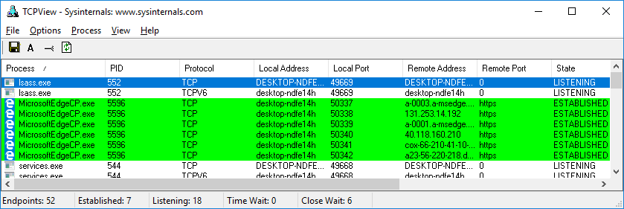

* + 1. Close the web browser.

### Question:

What did you observe in the TCPView window?

Type your answers here.

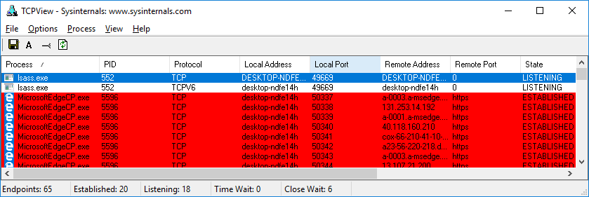

* + 1. Reopen the web browser. Research some of the processes listed in TCPView. Record your findings.

Type your answers here.

End of document